80721

SHINA A ODUKOYA DBA

INSPIRE ENVY APPAREL

604 FORTH WORTH AVE.
#3119
DALLAS TX 75208

Basic Business Checking

statement

November 1, 2020 to November 30, 2020

Account number 1883143958


Account summary

Beginning balance
on November 1, 2020 | $17,532.11
Plus deposits
Electronic deposits | $34,525.08
............................................................................................................................................................
Other deposits | $292.26
............................................................................................................................................................
Less withdrawals
ATM/Debit Card withdrawals | -$2,833.89
............................................................................................................................................................
Electronic (EFT) withdrawals | -$15,221.68
............................................................................................................................................................
Fees and service charges | -$68.09
.............................................................................................................................................................
Transfers to other accounts | -$200.00

Ending balance | $34,025.79
on November 30, 2020 | $34,025.79

Call

(800) 925-2160
Hearing impaired (TDD 800 822-6546)

Visit our web site

www.comerica.com

Write to us

COMERICA BANK

P.O. BOX 650282
DALLAS, TX 75265-0282

The Account Balance Fee for this statement period for this account is $0.00/$1,000. The Account Balance Fee for this statement period for this account is $0.00/ $1,000. Effective 1/1/21, the following fee changes and description changes will apply. Returned Item Fax Notification will be $12.00/item. Returned Item Additional Advice will be $10.00/item. Substitute Check Printing will be called Check Image Printing. Stop Payment will be called Manual Stop Payment for Six Months.

If you have any questions, please contact your relationship manager or call us at the phone number listed on this statement or visit your local banking center.

Page 1 of 4

Basic Business Checking statement

November 1, 2020 to November 30, 2020

Basic Business Checking account details: 1883143958

Electronic deposits this statement period

 |  |  | Reference numbers
Date | Amount | Activity | Customer | Bank
Nov 02 | 3,417.00 | Dep At 3202 N Fitzhugh Ave Dallas TX 1509 |  | 0M37259224
Nov 02 | 2,036.00 | Dep At 3202 N Fitzhugh Ave Dallas TX 1509 |  | 0M31259077
Nov 03 | 4,800.00 | Dep At 3202 N Fitzhugh Ave Dallas TX 1509 |  | 0M36169708
Nov 03 | 2,200.00 | Dep At 3202 N Fitzhugh Ave Dallas TX 1509 |  | 0M31173955
Nov 03 | 680.00 | Dep At 3202 N Fitzhugh Ave Dallas TX 1509 |  | 0M38173811
Nov 03 | 1,240.00 | Dep At 3202 N Fitzhugh Ave Dallas TX 1509 |  | 0M36169607
Nov 03 | 73.08 | Plt US 777-6592329 CA 1509 |  | 0M30 0
Nov 03 | 3,040.00 | Dep At 3202 N Fitzhugh Ave Dallas TX 1509 |  | 0M35174000
Nov 06 | 1,100.00 | Dep At 3202 N Fitzhugh Ave Dallas TX 1509 |  | 0M35254691
Nov 10 | 4,062.00 | Dep At 3202 N Fitzhugh Ave Dallas TX 1509 |  | 0M34244900
Nov 10 | 101.00 | Dep At 3202 N Fitzhugh Ave Dallas TX 1509 |  | 0M32244989
Nov 18 | 6,600.00 | Dep At 3202 N Fitzhugh Ave Dallas TX 1509 |  | 0M36236052
Nov 18 | 2,900.00 | Dep At 3202 N Fitzhugh Ave Dallas TX 1509 |  | 0M39236236
Nov 25 | 520.00 | Dep At 3202 N Fitzhugh Ave Dallas TX 1509 |  | 0M38214633
Nov 30 | 1,600.00 | Dep At 3202 N Fitzhugh Ave Dallas TX 1509 |  | 0M37244873
Nov 30 | 156.00 | Dep At 3202 N Fitzhugh Ave Dallas TX 1509 |  | 0M30244957

Total Electronic Deposits: $34,525.08

Total Number of Electronic Deposits: 16

Other deposits this statement period

 |  |  | Reference numbers
Date | Amount ($) | Activity | Customer | Bank
Nov12 | 292.26 | Mobile Deposit |  | 0440057711
Total Other Deposits: $292.26
Total Number of Other Deposits: 1

ATM/Debit Card transactions this statement period

 |  |  |  | Bank
Date |  | Amount ($) | Activity | reference
 |  | Amount ($) | Activity | number
 | Nov03 | -33.33 | Chevron 0206895 Dallas TX 1509 | 0M38688644
Nov03 |  | -100.00 | Cash App*dusan 4153753176 CA 1509 | 0M36269980
Nov05 |  | -35.00 | Wholefds 2510 Mckinne Dallas TX 1509 | 0M38391147
Nov09 |  | -2.37 | Whataburger 728 Dallas TX 1509 | 0M35549973
Nov10 |  | -16.23 | Cvs/pharm 10758--2501 Dallas TX 1509 | 0M37386585
Nov12 |  | -2,145.00 | Farfetch Los Angeles CA 1509 | 0M37629887
Nov19 |  | -2.00 | Plat Parking - Dallas TX 1509 | 0M32603048
Nov19 |  | -1.96 | Kroger #05294241 Capitol Dallas TX 1509 | 0M35264137
Nov27 |  | -498.00 | Tarrant Countys Lake Worth TX 1509 | 0M32104019

Total ATM/Debit Card Withdrawals: -$2,833.89

Total Number of ATM/Debit Card Withdrawals: 9

Electronic withdrawals this statement period

 |  |  | Reference numbers
Date | Amount ($) | Activity | Customer | Bank
Nov 03 | -128.73 | Citi Payment Payment 201102 |  | 9488506411
Nov 04 | -4,326.98 | Mcpp Park Distri Web Pmts 110420 |  | 9488202155
Nov 04 | -2,058.33 | Primrose School 4693990321 201102 |  | 9488747894
Nov 09 | -212.64 | Amex Epayment ACH Pmt 201109 |  | 9488049933

Page 2 of 4

Basic Business Checking statement

Basic Business Checking: 1883143958

Electronic withdrawals this statement period (continued)

 |  |  | Reference numbers
Date | Amount ($) | Activity | Customer | Bank
Nov 19 | -8,495.00Amex Epayment ACH Pmt 201119 |  |  | 9488394301
Total Electronic Withdrawals: -$15,221.68
Total Number of Electronic Withdrawals: 5

Fees and service charges this statement period

 |  |  | Bank
Date |  | Amount ($) Activity | reference
 |  | Amount ($) Activity | number
 | Nov 13 | -68.09 Service Charge | 0000030424

Total Fees and Service Charges: -$68.09

Total Number of Fees and Service Charges: 1

Transfers to other accounts this statement period

 |  |  |  | Bank
 |  |  |  | reference
Date | Amount ($) | Activity |  | number
Nov 18 | -200.00 | Web Funds Transfer To Account | Xxxxxx5908 | 0W52026358

Total Transferred to Other Accounts: -$200.00

Total Number of Transfers to Other Accounts: 1

Page 3 of 4

Basic Business Checking statement

November 1, 2020 to November 30, 2020

Basic Business Checking: 1883143958
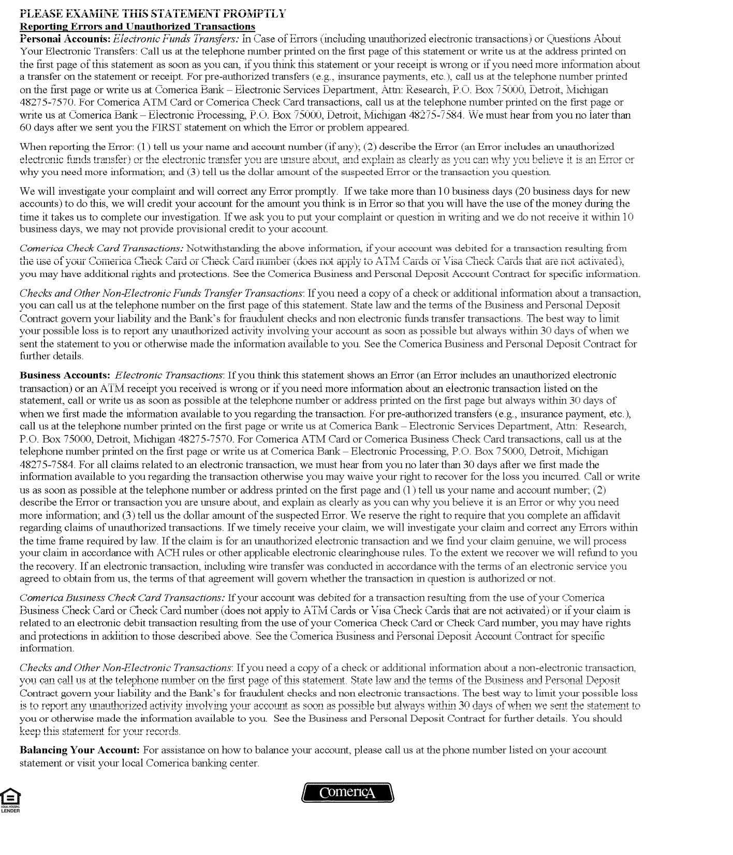

Equal Opportunity Lender Rev. 05-17 MEMBER FDIC

www.comerica.com
Page 4 of 4

